UNITED STATES
SECURITIES AND EXCHANGE COMMISSION
Washington, D.C. 20549
SCHEDULE 14A
Proxy Statement Pursuant to Section 14(a) of the
Securities Exchange Act of 1934
(Amendment No. )
Filed by the Registrant ☒ Filed by a party other than the Registrant ☐
Check the appropriate box:

☐ | Preliminary Proxy Statement
☐ | Confidential, for Use of the Commission Only (as permitted by Rule 14a-6(e)(2))
☐ | Definitive Proxy Statement
☒ | Definitive Additional Materials
☐ | Soliciting Material under §240.14a-12

Corsair Gaming, Inc.
(Name of Registrant as Specified In Its Charter)
(Name of Person(s) Filing Proxy Statement, if Other Than The Registrant)
Payment of Filing Fee (Check the appropriate box):

☒ | No fee required.
☐ | Fee paid previously with preliminary materials.
☐ | Fee computed on table below per Exchange Act Rules 14a-6(i)(1) and 0-11.

0000000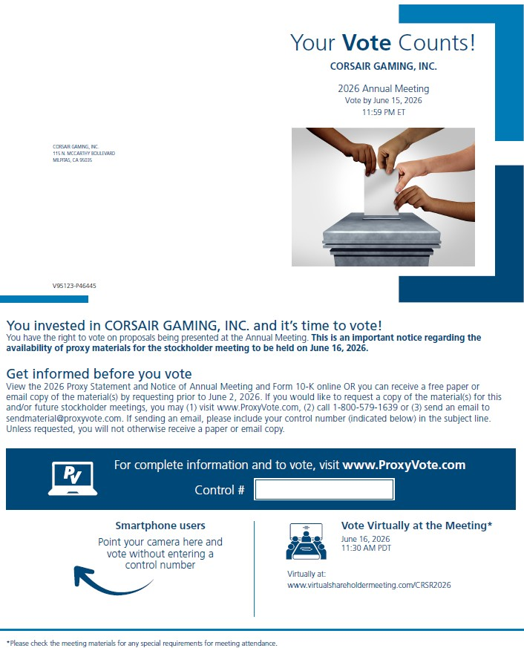
Your Vote Counts! CORSAIR GAMING, INC. 2025 Annual Meeting Vote by June 9, 2025 11:59 PM ET CORSAIR GAMING, INC. 115 N. MCCARTHY BOULEVARD MILPITAS, CA 95035 V73368-P26848 You invested in CORSAIR GAMING, INC. and it’s time to vote! You have the right to vote on proposals being presented at the Annual Meeting. This is an important notice regarding the availability of proxy materials for the stockholder meeting to be held on June 10, 2025. Get informed before you vote View the Proxy Statement and Form 10-K online OR you can receive a free paper or email copy of the material(s) by requesting prior to May 27, 2025. If you would like to request a copy of the material(s) for this and/or future stockholder meetings, you may (1) visit www.ProxyVote.com, (2) call 1-800-579-1639 or (3) send an email t

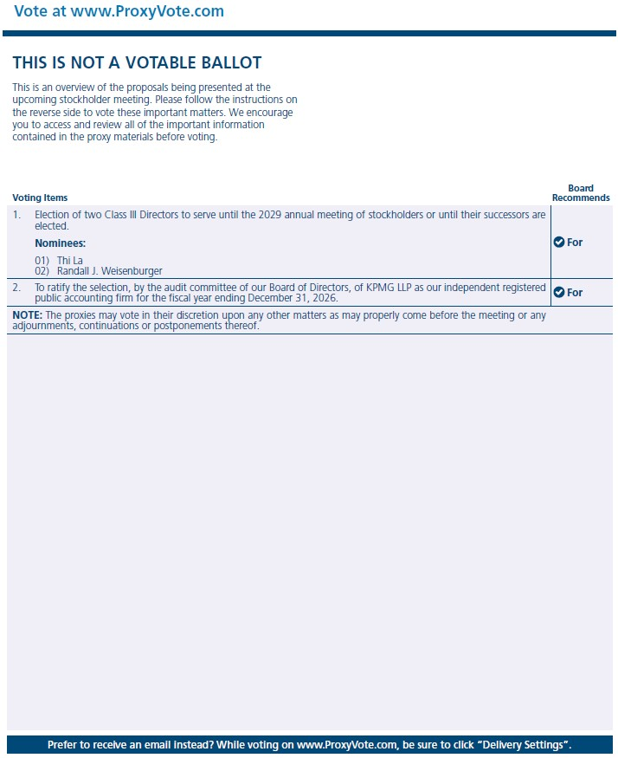 Vote at www.ProxyVote.com THIS IS NOT A VOTABLE BALLOT This

is an overview of the

